|  |
| --- |
| Close-up image showing the leaf-sides of two oversized books side-by-side on a bookshelf, with additional books in soft focus background |
| Planning Report  Simply Handy, West Lothian College |
| |  |  |  | | --- | --- | --- | | Juan Alvarez | 3/7/19 | HND Software Development 2018/9 | |

Contents

No table of contents entries found.

# 1 Introduction

## 1.1 Project overview

The beginning of the project is an approach by Simply Rugby, a Scottish based rugby club that is supported by the Scottish Rugby Union, to create an electronic format of the system they use currently.  
They have a paper-based system where they gather all information regarding

* players’ details of each squad (Junior and Senior)
* training records
* skills development
* and game records

and my aim is to computerise the system.

There would be some meetings with Simply Rubgy’s chairman, Thomas Sutherland Muir, who would explain the exact requirements and needs, and where I would be able to ask the needed questions to bring the project to a successful conclusion.

## 1.2 Dates and deadlines

The first deadline given with the project brief is the 3rd of May 2019, when the software must be installed in the client’s premises:

* Simply Rugby  
  Nile Street Stadium  
  Cowcaddens  
  Glasgow  
  G4 9QS

The contact details given are:

* Thomas Sutherland Muir – Chairman  
  Tel: 0141-1375028  
  Email: [tsmuir@srugby.co.uk](mailto:tsmuir@srugby.co.uk)

The first meeting with the client was the 6th of December 2018, in that meeting the brief was:

* There are 2 users: Admin and Coach
* They need secure login
* Admin can add, edit and delete Player details
* Coach should only have view access to Player details
* Coach should have edit access to Training records, Skills development and some of Game records
* Admin can add and edit part of the Game records
* We need to store the data in electronic format

After asking for some needed information regarding what player details, skills, training and game records to store in the system I was provided with a paper copy of 5 documents the club uses at this moment. Although I asked for some sample data, due to data protection I cannot have any records Simply Rugby has at this moment on time.

At this moment a second meeting was scheduled for the 17th of January 2019.

The following deadlines where as well given:

10th of January 2019 – Project Plan  
7th of March 2019 – Planning Report  
25th of April 2019 – Development (Tested implementation)  
23rd of May 2019 – Evaluation Report

## 1.3 Work after 1st meeting

The first thing to do was create a Project Plan to coordinate all the work that would be done during the whole project. As the image would be too big to include in this report, I include the file in the submission of the report. (Alvarez, SimplyRugby-Juan-AlvarezV1.0, 2019)

In the Project Plan I considered the needed time to gather requirements and do a proper analysis of the project. The design work would come afterwards follow by the development. As an agile approach is going to be follow some of the work will be done side by side, like for example Development and Testing. Once all the Testing is finished satisfactorily there is going to be a need to train the client’s employees and implement the software into their premises. All of it is detailed in the Project Plan. (Alvarez, SimplyRugby-Juan-AlvarezV1.0, 2019)

The first thing I gathered was some user stories to be able to understand better the needs of the client. (Alvarez, User Stories Juan Alvarez V1, 2019)

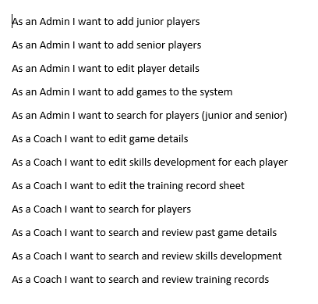

Fig 1

Based on the information I gathered in that exercise I initially designed a use case diagram where I could visualise the requirements of the program I needed to code. (Alvarez, Use Case Diagram Juan Alvarez V1, 2019)

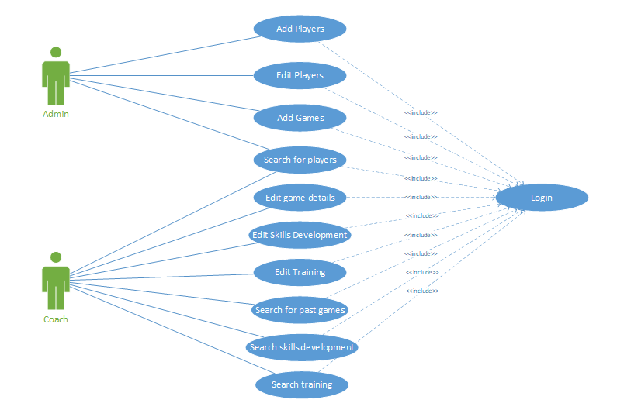

Fig 2

On that Use case diagram (Alvarez, Use Case Diagram Juan Alvarez V1, 2019) I included all the requirements the client informed off during our first meeting and used it as a bases to produce an original draft of the SRS (Alvarez, SRS Symply Handy Juan Alvarez, 2019) where all requirements informed at that time were included. Although the document was not completed, it was enough, together with the other documents, to present to the client in our second meeting so I could gain some feedback to ensure the client was happy with the direction the project was taking.

In the second meeting I would be able to gain more of an insight regarding what the client wanted so I could enter the next phase ensuring the client was happy with the completed work.

## 1.4 Second meeting

In the second meeting the project changed completely, the client informed that due to budget cuts there are some of the data that would not be included in the project.

It was stripped back to gathering the Name, SRU Number, Date of Birth, Phone number, Email and Squad of each player and in case the player was a junior player there would be a need to mark that Parental consent was given.

The admin would still be able to add, edit and search player details but the coach would only be able to view them. Additionally, the admin would be able to view all the emails hold in the system by a simple search.

The Player Profile sheet (skills development) would still be included in the system and the coach would be able to edit all the fields on it.

The rest of the previous requirements would be scrapped and left for future iterations depending on the budget.

The first thing I had to do after this meeting is go back to basics and rework all the requirements. I will go into all the work undertaken to achieve this in the Details Design section of this document latter.

## 1.5 Information Gathering and Identification of resources

The first part of the information gathering was the Project Brief provided by the client (Simply Rugby, 2018), based on that I gathered a few questions that was asked at the first interview with Thomas Muir.

Between those questions it was:

* Who is going to use the program?
* What data needs to be stored?
* Who can access what data?
* What player details the program needs to store?
* What player skills the program needs to store?
* What training details the program needs to store?
* What game details the program needs to store?
* What are the concerns with GDPR at the club?
* What data do you have now?

In the first meeting it transpired the following:

* There are 2 users, Admin and Coach.
* Admin can add, edit and delete player data.
* Coach can view player data.
* Admin can add games into the system.
* Coach can edit game details.
* Coach can edit players skills development.
* Coach can edit training sessions.
* Admin can search for all emails stored in the system.

The client provided some paper forms that they are using at this moment. (Simply Rugby, 2018)

But after the second meeting this was changed to:

* There are 2 users, Admin and Coach.
* Admin can add, edit and delete player data.
* Coach can view player data.
* Coach can edit players skills development.
* Admin can search for all emails stored in the system.

As the first step of the whole project was to create a Project Plan, I needed to dive a little bit into how to use MS Project, so I found a good tutorial online to be able to understand the basics of what I needed to create. (6D, 2016) I choose to do the project plan in MS project as it has all the needed functionality to be able to create the project and manage it from the begging to the end of the project. As well the fact that I already had it available and the cost would be zero was crucial in making that decision.  
In order to have correct data to complete the Project Plan I had to research the average salary of Project Managers (Paysale, 2018), Software Engineers (PayScale, 2018), Software Testers (PayScale, 2018), Personal Assistants (PayScale, 2018) and Software Developer (PayScale, 2018)

From the first moment I realised that I needed to develop a simple program, the end users are used to store these details in paper documents, so I planned to do a simple to use system where the data they needed, if possible, would be displayed in a single page for ease of use.

The best solution would be to create it using WPF forms with visual studio, and I already was comfortable using that solution and as well I investigating other alternatives, like using Windows Forms (D, 2013), but decided that using newer technology already readily available tried and tested would ensure the application was future proofed.

What I needed to research was how to implement the login page, so after looking a different solutions I found a tutorial that would come very handy for this purpose, after studying it, I was confident I knew what I had to do. (CodAffection, 2017)

As I was already proficient on using Visual Studio, I didn’t need to do any research on that front, but I had to do some research on data storage, as it would be needed to ensure the entered data into the system was accessible at latter stages when the end users needed them.

Very quickly I decided that binary files (tutorialspoint, 2018) and excel files (Bospear, 2017) were not ideal for this project as I consider a proper database solution a much more robust and future proofed method of storing the data.

Once I went into researching database solutions, I found that there was structured and non-structured solutions (Academind, 2018). I entertain the idea of using a non-structured solution (Curry, 2017) (Mongodb, 2019), but quickly realised that for this particular project a structured solution was better suited due to the fact that the requirements were clear and fix. The non-structure advantage when searching huge amounts of data was not suited to the small application and limited functionality Simply Rugby needed. In the case of the application I had to produced it would have been a disadvantage.

So I centred into investigating different solutions like Oracle (Oracle, 2019) and SQL Server (Microsoft, 2019) I decided that for the scope of this project a free version that is totally proven and reliable would be more suited. As budget constrains are an issue, as it transpired from the second meeting with the client, and this solution would give all the functionality the client needed without the added cost.

So, based on that reasoning MySQL (MySql, 2019) is the chosen solution for this particular project.

## 1.6 Aims of the Project

The aim of the project is to produce a working solution where Simply Rugby can store player details and skills development to keep an up to date record of their player base as well as the skills the coach can use in his day to day work.

The end result should be robust, easy to use and future proof.

## 1.7 Identification of materials required

There are several software we need to obtain for this particular project, listed on this table:

|  |  |  |
| --- | --- | --- |
| Material | Where it is obtained | Used for |
| MS Project | Microsoft Imagine | Project Plan |
| MS Office | Microsoft Imagine | Project documentation and reports |
| MS Visio | Microsoft Imagine | UML Diagrams |
| Visual Studio 2017 | Microsoft Imagine | Coding the solution |
| MySQL server | mysql.com | Storing data |

As all software was obtained free due to be a full-time student at West Lothian College and the chosen database solution has a free to use version this will mean on savings for the client.

# 2 Detail Design

## 2.1 Business Model

### 2.1.1 User Stories

After the second meeting with the client I needed to create a different version of user stories, this are the ones I eventually chose to go forward with:

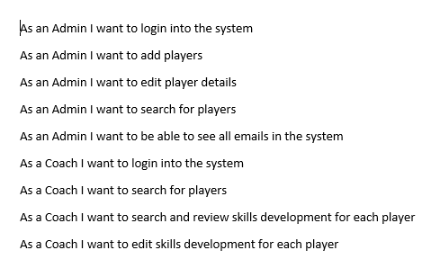

Fig 3 - (Alvarez, User Stories Juan Alvarez V1-1, 2019)

That was the needed requirements the client requested for the first version of the application.

### 2.1.2 Written Use Case Scenarios

The first step the user will have to do is login in to the system, so that is the first scenario.  
It can be found in the same folder as this planned report with the name WrittenUseCaseLogingIn (Alvarez, WrittenUseCaseLogingIn, 2019), in it I describe the flow the user needs to follow and what the user needs to interact with in order to be able to log in to the application Simply Handy.

The next natural step in the program is searching for players. That is reflected in the file WrittenUseCaseSearchPlayers (Alvarez, WrittenUseCaseSearchPlayers, 2019) where it explains the flow of actions needed for the user to be able to search players in the application.

In the case of the user Admin there is a functionality needed for adding players to the data base, that is reflected in the file WrittenUseCaseAddPlayers (Alvarez, WrittenUseCaseAddPlayers, 2019) where it explains how the Admin needs to be able to add players to the database.

The Admin needs to be able to edit players already stored in the database to keep their details up to date, that is reflected in the file WrittenUseCaseEditPlayers (Alvarez, WrittenUseCaseEditPlayers, 2019).

The Admin needs to be able to see all the players’ emails stored in the database. That is reflected in the use case named WrittenUseCaseViewEmails (Alvarez, WrittenUseCaseViewEmails, 2019).

The Coach needs to be able to search and review the skills development of each player, for that case I created the use case WrittenUseCaseSearchandReviewSkillsDevelopment (Alvarez, WrittenUseCaseSearchandReviewSkillsDevelopment, 2019).

The final written use case scenario is the need of the Coach to be able to edit player’s Skills Development. That is reflected in WrittenUseCaseEditSkillsDevelopment (Alvarez, WrittenUseCaseEditSkillsDevelopment, 2019)

All the use cases scenarios are complemented with the information in the updated SRS report produced after the second meeting with the client, since the first draft had to be updated heavily due to requirement changes. (Alvarez, SRS Simply Handy Juan Alvarez V1-2, 2019)

### 2.1.3 Activity Diagrams

Each activity diagram is linked to one of the written case scenarios mentioned above.

Starting with the ActivityDiagramLoginIn (Alvarez, ActivityDiagramLoginIn, 2019) and is linked with the LogginIn Written use case (Alvarez, WrittenUseCaseLogingIn, 2019)

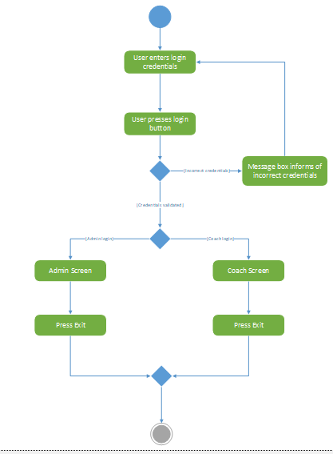

Fig 4 - (Alvarez, ActivityDiagramLoginIn, 2019)

The next diagram is the ActivityDiagramSearchingPlayer (Alvarez, ActivityDiagramSearchingPlayer, 2019) and is linked with the Search use case (Alvarez, WrittenUseCaseSearchPlayers, 2019).

The next diagram is the ActivityDiagramAddingPlayer (Alvarez, ActivityDiagramAddingPlayer, 2019) that is linked with the AddingPlayer written use case (Alvarez, WrittenUseCaseAddPlayers, 2019).

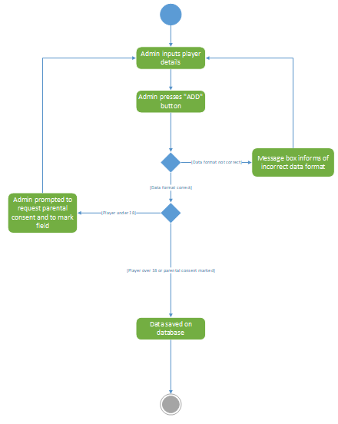

Fig 5 - (Alvarez, ActivityDiagramAddingPlayer, 2019)

The next diagram is the need for the Admin to edit players, reflected in the diagram ActivityDiagramEditPlayer (Alvarez, ActivityDiagramEditPlayer, 2019) that is linked to the use case EditPlayer (Alvarez, WrittenUseCaseEditPlayers, 2019).

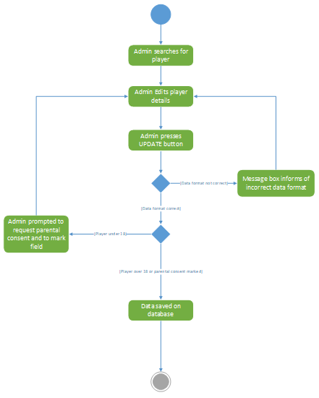  
Fig 6 - (Alvarez, ActivityDiagramEditPlayer, 2019)

The last activity diagram for the user Admin is ActivityDiagramViewEmails (Alvarez, ActivityDiagramViewEmails, 2019) that is linked with the use case for viewing emails (Alvarez, WrittenUseCaseViewEmails, 2019).

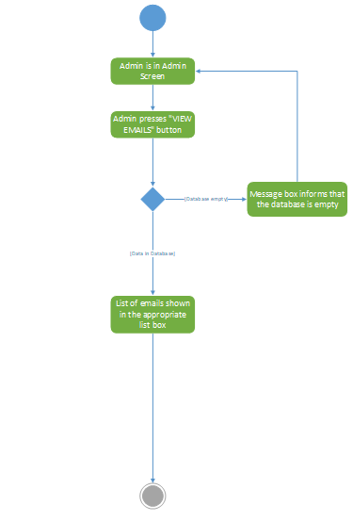  
Fig 7 - (Alvarez, ActivityDiagramViewEmails, 2019)

The final activity diagram is the only one exclusive to the user Coach, it is ActivityDiagramEditSkillsDevelopment (Alvarez, ActivityDiagramEditSkillsDevelopment, 2019) that is linked with the written use case for editing players’ skills development (Alvarez, WrittenUseCaseEditSkillsDevelopment, 2019)

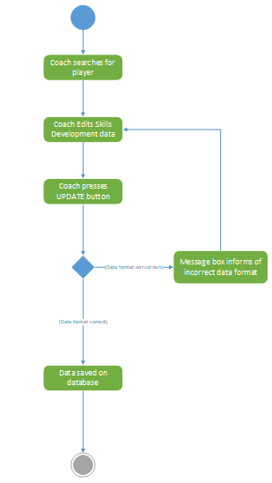  
Fig 8 - (Alvarez, ActivityDiagramEditSkillsDevelopment, 2019)

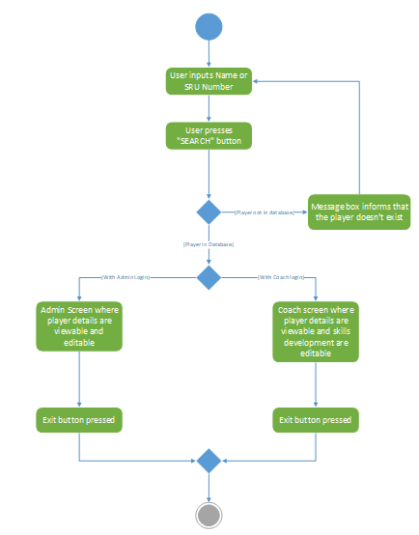

Fig 9 - (Alvarez, ActivityDiagramSearchingPlayer, 2019)

### 2.1.4 Sequence Diagrams

As the aim of this project is to try and simplify as much as possible the experience for the user and the coding of the software so it can be easily maintained, there are not many complex cases that we need to develop in sequence diagrams, so only 2 where chosen.

The first one is the SequenceDiagramLoginIn (Alvarez, SequenceDiagramLoginIn, 2019) that is linked with the login in use case scenario (Alvarez, WrittenUseCaseLogingIn, 2019) and with the login activity diagram (Alvarez, ActivityDiagramLoginIn, 2019).

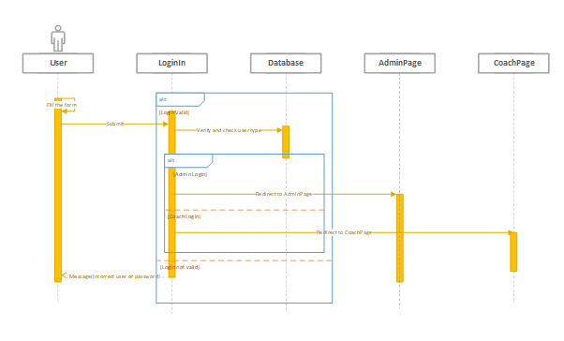  
Fig 10 - (Alvarez, SequenceDiagramLoginIn, 2019)

The other one chosen to be represented is SequenceAddingPlayer (Alvarez, SequenceAddingPlayer, 2019), this is linked with the adding player written use case scenario (Alvarez, WrittenUseCaseAddPlayers, 2019) and the activity diagram for adding players to the database (Alvarez, ActivityDiagramAddingPlayer, 2019).

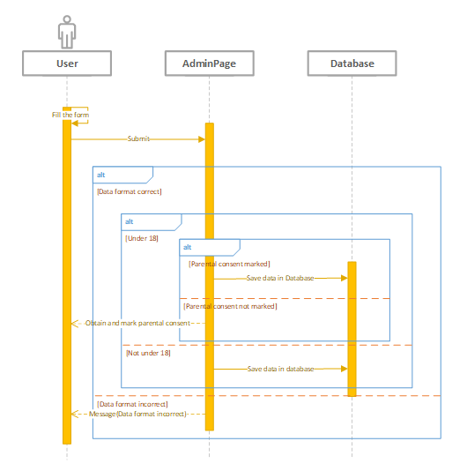  
Fig 11 - (Alvarez, SequenceAddingPlayer, 2019)

### 2.1.5 Class Diagram

The first thing to look at in this section is the CRC cards where the Class Diagram will be based.

2.1.5.1 CRC Cards